University of Washington

iSchool Info 330

# Module 04 Assignment - SQL Programming

In this module's assignment, you will learn how database designs are improved with the addition of the abstraction layer objects Views and Functions.

## Assignment Videos

Please watch the following Videos:

|  |
| --- |
| Assignment Videos < 120 min (Links are to external sites) |
| [SQL Join Statement - 25](https://youtu.be/AWEyxLweCqc) |
| [Functions-01 Using Built In Functions - 34](https://www.youtube.com/watch?v=ShQ6Wm1pNks&index=1&list=PLfycUyp06LG_ShpiOSTkQmu69sZD2Ng13) |
| [Functions-02 User Defined Functions UDFs - 12](https://youtu.be/XEiQ3M2LhU4?list=PLfycUyp06LG_ShpiOSTkQmu69sZD2Ng13) |
| [Functions-03 Functions for Reporting - 12](https://youtu.be/BWw5YUv49c4?list=PLfycUyp06LG_ShpiOSTkQmu69sZD2Ng13) |
| [Functions-04 Using Functions for ETL Processing -3](https://youtu.be/URSjRbN1rCQ?list=PLfycUyp06LG_ShpiOSTkQmu69sZD2Ng13) |
| [Functions-05 Using a UDF for a Check Constraint - 6](https://youtu.be/NxNJJvG7FzU?list=PLfycUyp06LG_ShpiOSTkQmu69sZD2Ng13) |
| [SQL Server Programming Part 1 - Stored Procedure Basics - 10](https://youtu.be/fjNsRV4zLdc) |
| [Using SQL Variables in a Batch - 2](https://youtu.be/_3uXP6SIYBs) |

## Assignment Examples

Read and try out some SQL statements on the W3Schools website. This website has short articles about many subjects and we will use this site throughout the course. In many of these articles you will find a "Try it Yourself" section where you can experiment with the SQL language interactively. You only need to scan though these pages so don't spend a lot of time on each.

This website will become one of your most used "Go To" sites as you progress in your learning. So please check out the following pages this week!

|  |
| --- |
| Examples < 60 min (Links are to external sites) |
| [SQL Joins](https://www.w3schools.com/sql/sql_join.asp) - 5 |
| [SQL Views](https://www.w3schools.com/sql/sql_view.asp) - 5 |
| [User-defined functions](https://en.wikipedia.org/wiki/User-defined_function) - 5 |
| [SQL Insert Into](https://www.w3schools.com/sql/sql_insert.asp) - 5 |
| [SQL Update](https://www.w3schools.com/sql/sql_update.asp) - 5 |
| [SQL Delete](https://www.w3schools.com/sql/sql_delete.asp) - 5 |
| [SQL Auto Increment](https://www.w3schools.com/sql/sql_autoincrement.asp) - 5 |
| [SQL Injection](https://www.w3schools.com/sql/sql_injection.asp) - 5 |

## Assignment Reading

Since the course does not have an official text you will use various websites for your studies. This is a great way to learn new subjects and practicing it will be something you will use for years to come! Please read the following web pages:

|  |
| --- |
| Reading < 120 min (Links are to external sites) |
| [SQL - Using Views - 30](https://www.tutorialspoint.com/sql/sql-using-views.htm) |
| [User Defined Functions in SQL - 60](https://www.tutorialgateway.org/user-defined-functions-in-sql/) |
| [SQL Transactions - 20](https://www.tutorialspoint.com/sql/sql-transactions.htm) |

## Assignment Document

Write a one-page document that articulates the answers to the following questions. Use at least one well-formed paragraph per question. Using only a sentence or two is fine, but it must make sense and be well formed. (Please use MS Word or a compatible word processor)

1. Explain why Views are an important part of a RDMS.
2. Explain the differences between a view and a custom table function (UDF).
3. Explain the differences between a view and a stored procedure.

***Important:*** *Your document must look professional to get full points! Use my example template and video, in the General Files and Topics module, as a guide for what I expect a professional paper to look like. Make sure you format it like a college paper instead of the text message. Things like your name, date, class, citations, introductory and summary paragraphs are always expected! Not putting these in the document you will cost you!*

## Assignment Task

I would like you to practice what you have learned in this module.

In this scenario, our CEO has learned to perform basic SQL selects in the database, needs help with more complex ones. To help her, we will **create SQL views that answers several requests** for data found in the Northwind database.

Your project manager has volunteered you to create these views! He has emailed her saying they are complete, but you still have not made them! You have better get busy and get them in place!

**Tip**: You can use the provide SQL file, Assignment04.sql, to get you started.

### Step 1: Review the letter the PM is sending

"Hello, Jane!

I have created the following views to help get the information you have requested in the past.

-- Data Request: 0301

-- Request: I want a list of customer companies and their contact people

**Select * from vCustomerContacts;**

-- Data Request: 0302

-- Request: I want a list of customer companies and their contact people, but only the ones in US and Canada

**Select * from vUSAandCanadaCustomerContacts;**

-- Data Request: 0303

-- Request: I want a list of products, their standard price and their categories. Order the results by Category Name and then Product Name, in alphabetical order.

**Select * from vProductPricesByCategories;**

-- Data Request: 0323

-- Request: I want a list of products, their standard price and their categories. Order the results by Category Name and then Product Name, in alphabetical order but only for the seafood category

**Select * from dbo.fProductPricesByCategories('seafood');**

-- Data Request: 0317

-- Request: I want a list of how many orders our customers have placed each year

**Select * from vCustomerOrderCounts;**

-- Data Request: 0318

-- Request: I want a list of total order dollars our customers have placed each year

**Select * from vCustomerOrderDollars;**

Hope these help! I worked really hard on getting created for you!

Bill Lumbergh"

### Step 2: Create the Views and Functions

Now create the reporting views and functions that are promised!

* **vCustomerContacts**

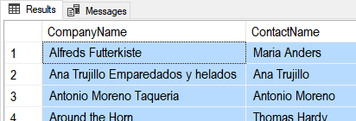

#### Figure 1. The results of vCustomerContacts

* **vUSAandCanadaCustomerContacts**

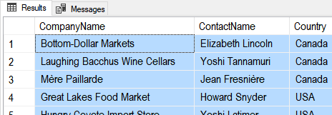

#### Figure 2. The results of vUSAandCanadaCustomerContacts

* **vProductPricesByCategories**

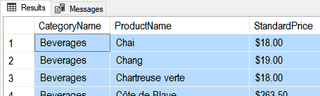

#### Figure 3. The results of vProductPricesByCategories

* **fProductPricesByCategories('Seafood')**

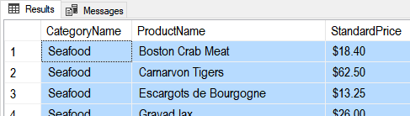

Figure 4. The results offProductPricesByCategories

* **vCustomerOrderCounts**

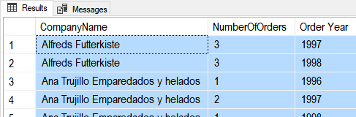

#### Figure 5. The results of vCustomerOrderCounts

* **vCustomerOrderDollars**

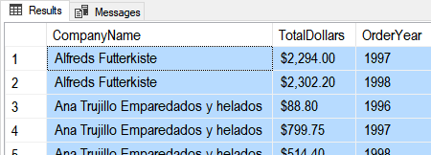

#### Figure 6. The results of vCustomerOrderDollars

# Grading

Student work will be evaluated on a point system using the following general guidelines found on the Course Syllabus page. Make sure you read and understand this.

**NOTE:**  It is very possible to get a 3.9 or better from this course, but you have to earn it! Do not expect to get 100% of the possible points without extra effort on your part. If you want to excel in this course, you must submit **excellent**work!

# Submit your work

After you have completed your Word document and SQL Script, place both into a folder called Assignment04**FirstInitialLastName** and Zip the folder. Upload the Zipped folder to the Canvas web site.

